Lab 2: Report

10/29/16

Garrett Jacobsen

Evan Susag

Seth Williams

Part I: master.py

The Master server file is programmed in the most recent release of Python 2.7. Python command line input will be sufficient to access and run the server file on Tux systems. Master.py can be compiled and run by running “python master.py” (without quotes) on command line. See the demonstration below:

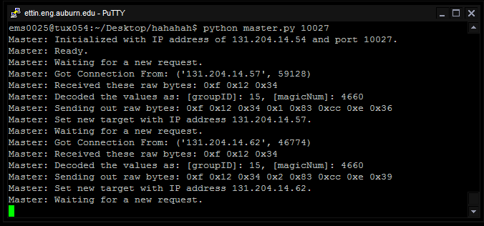

The Master will listen for a Slave, receive packets, verify a valid join request, and then send back a GroupID and Target for the Slave’s use in the Ring

Part II: slave.c

The Slave was written in C, as instructed. See the demonstration below for an example of compilation and running (next page):

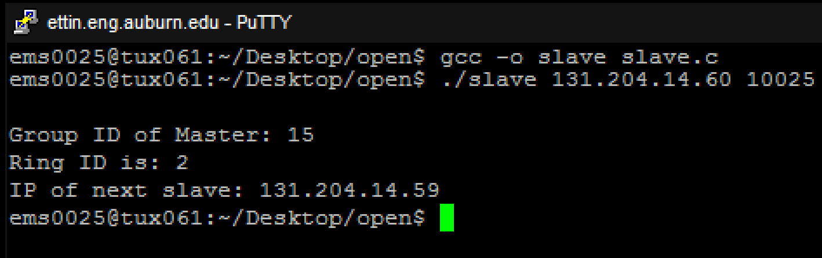

slave.c can be compiled by running “gcc –o slave slave.c” (without quotes) on command line. Once compiled, and once the Master is launched, the Slave can send a join request to the master. The user inputs the hostname (or IP address), and listening port of the Master, and the program will form a join request, and then show the relevant response information received from the Master.